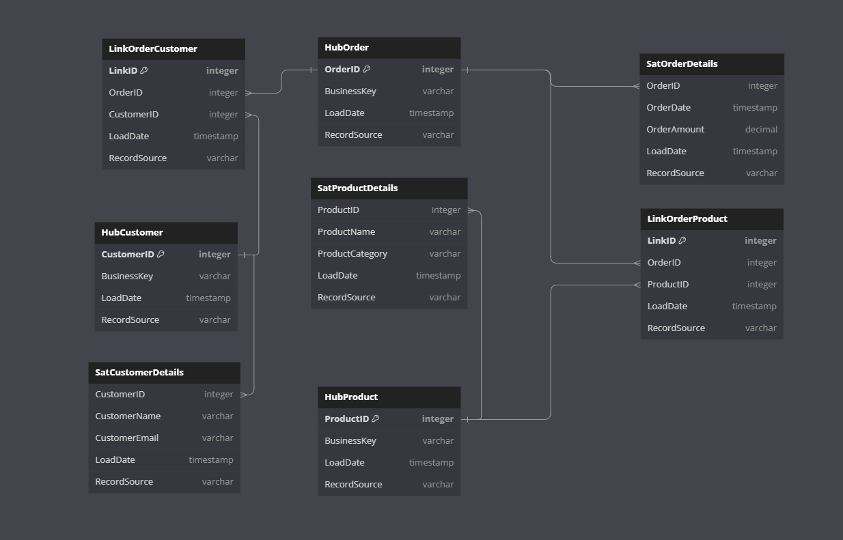

Рисунок 1. Структура БД.

// Hub-таблицы

Table HubCustomer {

  CustomerID integer [primary key]

  BusinessKey varchar

  LoadDate timestamp

  RecordSource varchar

}

Table HubProduct {

  ProductID integer [primary key]

  BusinessKey varchar

  LoadDate timestamp

  RecordSource varchar

}

Table HubOrder {

  OrderID integer [primary key]

  BusinessKey varchar

  LoadDate timestamp

  RecordSource varchar

}

// Link-таблицы

Table LinkOrderProduct {

  LinkID integer [primary key]

  OrderID integer

  ProductID integer

  LoadDate timestamp

  RecordSource varchar

}

Table LinkOrderCustomer {

  LinkID integer [primary key]

  OrderID integer

  CustomerID integer

  LoadDate timestamp

  RecordSource varchar

}

// Satellite таблицы

Table SatCustomerDetails {

  CustomerID integer

  CustomerName varchar

  CustomerEmail varchar

  LoadDate timestamp

  RecordSource varchar

}

Table SatProductDetails {

  ProductID integer

  ProductName varchar

  ProductCategory varchar

  LoadDate timestamp

  RecordSource varchar

}

Table SatOrderDetails {

  OrderID integer

  OrderDate timestamp

  OrderAmount decimal

  LoadDate timestamp

  RecordSource varchar

}

// Определение связей между таблицами

Ref: LinkOrderProduct.OrderID > HubOrder.OrderID // many-to-one

Ref: LinkOrderProduct.ProductID > HubProduct.ProductID // many-to-one

Ref: LinkOrderCustomer.OrderID > HubOrder.OrderID // many-to-one

Ref: LinkOrderCustomer.CustomerID > HubCustomer.CustomerID // many-to-one

Ref: SatCustomerDetails.CustomerID > HubCustomer.CustomerID // many-to-one

Ref: SatProductDetails.ProductID > HubProduct.ProductID // many-to-one

Ref: SatOrderDetails.OrderID > HubOrder.OrderID // many-to-one